APPLICATION FORMS

QuickStart

Capacity Building and Technical Assistance Program on
Community-Partnered Participatory Research
that Addresses Breast Cancer

Release Date: March 6, 2023
Submission Date:
- Individual community members or academics who need help finding a partner: March 20, 2023, 5:00 PM PST
- Community-Academic teams (new or existing): April 17, 2023, 5:00 PM PST.

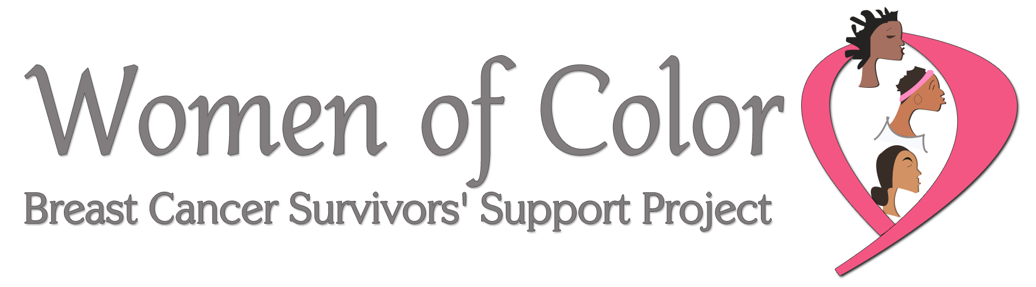

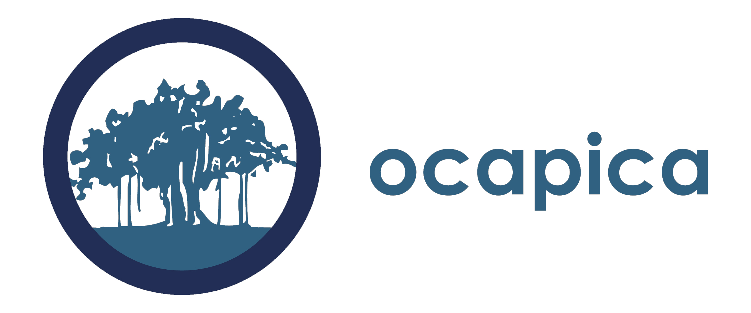
APPLICATION FORMS & EXCERPT FROM REQUEST FOR APPLICATIONS
Capacity Building and Technical Assistance Program on Community-Partnered Participatory Research that Addresses Breast Cancer

PROGRAM DETAILS

How will the program be structured?
QuickStart includes both face-to-face sessions and online sessions. The first face-to-face includes a welcoming dinner session followed by two full days. The second face-to-face is two full days.

We plan to have one in-person session take place in the Greater Los Angeles area and the other take place in the San Francisco Bay Area. Please note: Once the geographic distribution of accepted teams is known, it may be necessary to revise this plan so that both sessions take place in the San Francisco Bay Area. As noted below, transportation will be covered for California-based participants, regardless of location. Before applying, please consider your availability for the additional time needed for travel.

The face-to-face sessions will be a combination of presentations, small group work and work as individual teams. Participants must attend all sessions of the face-to-face meetings.

The technical assistance calls will take place using videoconference software (e.g. Zoom). Four rounds of calls will take place between face to face sessions, after the second face to face session, after concept proposals are submitted and after an optional mock review of the draft proposals

The online sessions reinforce and expand on the learning that takes place in the face-to-face sessions. The online portion is “asynchronous” – you and your partner will engage with the rest of the class, online, at any time of the day or night. Online sessions will occur using a private online file sharing and storage site. The online site will have additional instructions, materials for download, and homework for the partnerships to complete. The online site will be complemented with a messaging site/app that will be used for participants to maintain contact and share ideas throughout the program. Webinars will also be hosted (schedule to be announced).

It is the intention of this program that qualified participants (i.e. those based in California) will prepare for and submit a grant proposal to: CBCRP’s Community Research Collaboration in the spring of 2024. Participants will be encouraged to submit the grant proposal to other funders as well.

What is the time commitment?
- The full QuickStart program is scheduled for June 2023–January 2024.
- Two two-day face-to-face sessions, and potentially one opening dinner session (50 hours total)
- Online weekly assignments before and after face-to-face sessions. Assignments include literature reviews, developing draft research questions, writing concept papers, participating in educational webinars and others. (Approximately 10 hours of educational sessions plus written assignments)
- Four technical assistance calls to give teams feedback on potential research questions, methodologies, partnership development and concept papers. (4 hours)

QuickStart Key Dates & Activities
Activity | Dates | Notes
Online Sessions (OL)​ | June – December
Face-to-face meetings (F2F) | July 20-21, 2023​  August 21-22, 2023 | Face-to-face meeting 1: July 20 -21, 2023; 8:00 AM - 7:30 PM both days. Tentatively planned for Bay Area CA.  Face-to-face meeting 2: August 21 & 22; 8:00 AM - 7:30 PM both days. Tentatively planned for Southern CA.
Technical assistance calls (TA) | June – January
Concept paper due | October 6, 2023
Mock applications due | December 6, 2023
Mock application review | January 12, 2024 (tentative)

What is the financial commitment?
- The program is offered free of charge.
- Participants who live in California and do not live within a reasonable driving distance of the program sites will be provided transportation costs and offered a free, shared hotel room with another participant (either from your team or another team).
  - If participants would like a private hotel room, they are welcome to pay for it themselves. Local participants should plan to sleep at home.
- Participants from outside California will need to cover their own travel expenses, though the cost of the program and hotels will be covered.
- Breakfast and lunch will be provided for all participants during the program. There will be a limited number of group dinners included. Participants will need to pay for their own dinners on the nights when no group activities are planned.
- Participants are required to have their own computer and online access.
- Costs associated with regular partnership work that takes place outside of the program (phone calls, transportation to meetings etc.) will be paid by the individuals themselves.

Evaluation of the Program
All QuickStart participants will be invited to participate in the evaluation of the program. The evaluation structure and content is overseen by the Institutional Review Board of UC Irvine.

For more information or technical assistance, contact: Senaida Poole, Ph.D., Program Officer for Community Initiatives and Public Health Sciences, CBCRP; QuickStart@cabreastcancer.org.

About the QuickStart sponsoring organizations

California Breast Cancer Research Program (CBCRP)
CBCRP is the largest state-funded breast cancer research effort in the nation whose mission is to eliminate breast cancer by leading innovation in research, communication, and collaboration in the California scientific and lay communities. One of the primary funding mechanisms is the Community Research Collaboration (CRC) Awards, which provide $150,000 to $600,000 of funding (plus indirect funds) for partnerships of California-based community organizations and research academics. CBCPR also funds the California Breast Cancer Prevention Initiatives, which focus carefully crafted research initiatives on the effects of the environment on the development of breast cancer, why some groups of women are more likely to get breast cancer or to die from the disease, and breast cancer prevention. Learn more about CBCRP by www.cabreastcancer.org. There you will find additional information about the program, including their focus on community-partnered participatory research.

OCAPICA
The Orange County Asian and Pacific Islander Community Alliance (OCAPICA) is dedicated to enhancing the health, and social and economic well-being of underserved communities in Orange County, California. Established in 1997, OCAPICA serves more than 40,000 community members a year through programs in health, mental health, education, youth development, workforce development, and civic engagement. OCAPICA has more than 100 staff that speak 26 languages including ASL. To learn more about OCAPICA, visit www.ocapica.org.

WOMEN OF COLOR BREAST CANCER SURVIVORS’ SUPPORT PROJECT
WOC was created to help survivors navigate the world of recovery and develop self-care plans to aid in their survivorship. Our mission is to support breast cancer survivors, to offer crisis intervention in the healing process, to educate women and families on breast health, and to actively participate in effective change as it relates to health and racial disparities. ​ To learn more about OCAPICA, visit www.woc4you.org.

QuickStart Application Guidelines for
New and Existing Community-Academic Partnerships

Together the Academic co-PI and Community co-PI should fill out the partnership overview on next page and provide complete answers to questions A-C on the following page. Combine all pages of the application into a single word document and email it to QuickStart@cabreastcancer.org by 5:00 PM PDT on April 17, 2023.

Your complete application (excluding letters of reference and resumes/CVs) should not exceed six pages. A downloadable word version of this is also available on the QuickStart webpage: http://cbcrp.org/funding-opportunities/crc/quick-start-training.html

Please submit your application as a word document.

Application Checklist:
Please include the following in your completed application:

- Partnership overview: See form on page 6.
- Application questions: See questions on page 7.
- Letter of Reference. Each of the partners includes a letter of reference from an organization or individual familiar with his/her work. For academic partners, a letter from a previous collaborator is appropriate. For community partners, a letter from your community organization in support of this application is required.
- Resume or Curriculum Vitae (CV) (Not to exceed 4 pages). Each partner must submit either a resume (community partner) or a CV (academic partner) that is not to exceed four pages.

Mentorship plan request: For accepted academically-trained academic applicants with less than five years post-doctoral experience as a researcher, or without NIH R01 funding, an acceptable plan to gain mentorship from a seasoned investigator is required prior to the start of QuickStart.

Please note: The packet for completing and submitting a mentorship plan will be provided to the academic Co-PI after the acceptance of the team. A mentorship plan will not be required of the community Co-PI.

Partnership overview for Academic and Community Partners

Community Co-PI Name
Organization Name
Address
Email
Work Phone
Cell Phone
Fax Number
Executive Director Name
Work Phone
Email
Academic Co-PI Name
Institution
Address
Email
Work Phone
Cell Phone
Fax

How many years has your team worked together? Or, If this is a new partnership, how did you meet?
What previous research studies have you conducted together (if applicable)?
Who is your community of interest?
What disparities issues are of most concern to you?
What environmental issues in breast cancer are of most concern to you?
If you are not planning to investigate disparities and/or environmental issues in breast cancer what are your primary issues of concern?
Will the academic Co-PI be submitting a mentorship plan? (See requirements on page 3). If not, please indicate how many post-doctoral years has the person been working in the research field. Please also list the year, funder, and name of study of most recent NIH RO1 funding.

A. Overview of your partnership (2–3 pages).
Together the community co-PI and academic co-PI prepares a two to three page overview in response to the questions below. Please include the questions with the answers filled in underneath when you submit.

  - Who is part of your partnership? What experience, interests, and skills do they bring?

  - Describe your experience and position in your organization/institution.

  - How did your partnership meet and why have you chosen to work together? If you are an existing partnership, how did you begin to work together and what is your history of working together?

  - Describe each partner’s experience working in partnerships and/or collaborations (other than above) and (if applicable) in community-partnered participatory research.

  - Describe your common research interests. For example, describe the types of research questions that are interesting to you.

  - If there are other individuals who are likely to be significantly involved in the research process with your partnership, please describe them and their proposed contribution. Please note: if you would like one of them to be considered for participation in the program, please indicate who they are and why it would be important for them to participate. QuickStart cannot guarantee that more than two partners will be able to participate in the program; however, we will consider a third partner if there is available space.

B. Description of the Organization/Institution Involved (1–2 pages each). Each partner prepares a one to two page overview of their organization/institution they will represent in the QuickStart program,, that includes the following details. Please include the questions with the answers filled in underneath when you submit.

- Describe the mission of the organization/institution, the issue the organization/institution focuses on, the geographic reach of the organization/institution, the demographics of the population the organization/institution serves, and the types of services the organization/institution provides.
- Describe your organization/institution’s experience collaborating with others.

- Describe the research interests of the organization/institution (if different than above).

- Given the research needs and interests of the organization/institution, why is the individual applying a good candidate for this program?

- How will the organization/institution select a replacement for the individual if he/she resigns his/her position with the organization/institution?

C. Is there anything else you would like the QuickStart team to know as we consider your application?
QuickStart Application Guidelines for
Community Co-PIs seeking an Academic Co-PI

The Community co-PI should fill out the overview form on the next page and provide a narrative overview in response to the questions on the following page. Combine all pages of the application into a single word document and email it to QuickStart@cabreastcancer.org by March 20, 2023, 5pm PST.

If the community co-PI is selected for the QuickStart program, the team will assist them in identifying and reaching out to potential academic co-PIs to work with. Additionally, we will make introductions to people if we know of potential candidates. The QuickStart team cannot promise that the community co-PI will be able to find a partner in advance of starting the program, however all reasonable efforts will be made to facilitate a match.

Your complete application (excluding letters of reference and resumes) should not exceed six pages. A downloadable word version of this is also available on the QuickStart webpage: http://cbcrp.org/funding-opportunities/crc/quick-start-training.html

Please submit your application as a word document.

Application Checklist:
Please include the following in your completed application:

- Overview of Community Partner Seeking an Academic Co-PI: See form on page 9.

- Application questions: See questions on page 10.

- Letter of Reference. Includes a letter of reference from the organization you represent demonstrating support for your participation in QuickStart.

- Resume (Not to exceed 4 pages).

Overview of Community Partner Seeking an Academic Co-PI

Community Co-PI Name
Organization Name
Address
Email
Work Phone
Cell Phone
Fax Number
Executive Director Name
Work Phone
Email
Please describe the community you are a part of and/or represent.

What are the primary issues related to breast cancer that affect your community?

What disparities issues are of most concern to your community?

What environmental issues related to breast cancer are of most concern to your community?

Have you or your organization worked on a research project before? If so, please briefly describe.

Application Questions for a Community Co-PI Seeking an Academic Co-PI

Prepare a two to three page overview in response to the questions below. Please include the questions with the answers filled in underneath when you submit.

- Describe the mission of your organization, the issues the organization focuses on, the geographic reach of the organization, the demographics of the population the organization serves, and the types of services the organization provides.
- Describe your role in your organization. What experience, interest and skills do you have that are relevant to conducting community-partnered participatory research?

- Describe your experience working in partnerships and/or collaborations generally and (if applicable) in community-partnered participatory research.
- Describe your organization’s experience collaborating with others beyond what you describe in #3.

- Describe your research interests. For example, describe the types of research questions that are interesting to you and the group/organization you are representing. Please be as detailed as possible. This is important if you would like assistance finding a academic partner. The more we know about your interests, the better we will be able to help you.

- If there are other individuals who are likely to be significantly involved in the research process from your community group or organization, please describe them and their proposed contribution. Please note: if you would like one of them to be considered for participation in the program, please indicate who they are and why it would be important for them to participate. QuickStart cannot guarantee that more than the community co-PI and academic co-PI will be able to participate in the program; however, we will consider a third partner if there is available space.

- Given the research needs and interests of the organization, why is the individual applying a good Community Co-PI candidate for this program?

- How will the organization select a replacement for you if you resign from your position?

- Is there anything else you would like the QuickStart team to know as we consider your application?
QuickStart Application Guidelines for
Academic Co-PIs seeking a Community Co-PI

The Academic co-PI should fill out the overview form on the next page and provide a narrative overview in response to the questions on the following page (page 18). Combine all pages of the application into a single word document and email it to QuickStart@cabreastcancer.org by March 20, 2023, 5pm PST.

If the academic co-PI is selected for the QuickStart program, the team will assist them in identifying pathways to identifying and reaching out to potential community co-PIs to work with. Additionally, we will make introductions to community members if we know of potential candidates. The QuickStart team cannot promise that the academic co-PI will be able to find a partner in advance of starting the program, however all reasonable efforts will be made to do this.

You complete application (excluding letters of reference and resumes) should not exceed six pages. A downloadable word version of this is also available on the QuickStart webpage: http://cbcrp.org/funding-opportunities/crc/quick-start-training.html

Please submit your application as a word document.

Application Checklist:
Please include the following in your completed application:

- Overview of Academic Co-PI Seeking a Community Co-PI: See form on page 12.

- Application questions: See questions on page 13.

- Letter of Reference. Includes a letter of reference from the organization you represent demonstrating support for your participation in QuickStart.

- Resume or CV (Not to exceed 4 pages).

Overview of an Academic Co-PI Seeking a Community Co-PI

Academic Co-PI Name
Institution
Address
Email
Work Phone
Cell Phone
Fax Number
Please give some key words of the type of scientific research you are qualified to do (ex. Toxicology, Epigenetics, etc)

Have you worked on either breast cancer in the past? Please describe briefly.

Have you worked on disparities-related research in the past? Please describe briefly.

Have you worked on environmental exposures-related research in the past? Please describe briefly.

Will you be submitting a mentorship plan? (See requirements on page 9). If not, please indicate the number of post-doctoral years completed in the research field. Please also list the year, funder, and name of study of most recent NIH RO1 funding.

Application Questions for an Academic Co-PI Seeking a Community Co-PI

Prepare a two to three page overview in response to the questions below. Please include the questions with the answers filled in underneath when you submit.

- Describe the mission of your institution, research priorities and focus, geographic reach (if relevant), the demographics of the population(s) served, etc.
- Describe your role in your institution. What experience, interest and research skills do you have that are relevant to conducting community-partnered participatory research?

- Describe your experience working in partnerships and/or collaborations generally and (if applicable) in community-partnered participatory research.

- Describe your institution’s experience collaborating with others beyond what you describe in #3.

- Why are you interested in being part of a CPPR team?

- Describe your research interests. For example, describe the types of research questions that are interesting to you. Please be as detailed as possible. This is important if you would like assistance finding a community partner. The more we know about your interests, the better we will be able to help you.

- If there are other individuals who are likely to be significantly involved in the research process from your institution, please describe them and their proposed contribution. Please note: if you would like one of them to be considered for participation in the program, please indicate who they are and why it would be important for them to participate. QuickStart cannot guarantee that more than one academic co-PI will be able to participate in the program; however, we will consider a third partner if there is available space.

- Given the research needs and interests of the institution, why is the individual applying a good Academic Co-PI candidate for this program?

- How will your team maintain quality scientific leadership of this project if you resign from your position at your institution or organization?

- Is there anything else you would like the QuickStart team to know as we consider your application?

